|  |  |
| --- | --- |
| Student Name | **Arbab Hussain Qureshi** |
| Roll Number | **22SW028** |
| Section | **01** |

**DBS LAB # 05 – Data Definition Language**

**Tasks:**

**1. Create Statement**

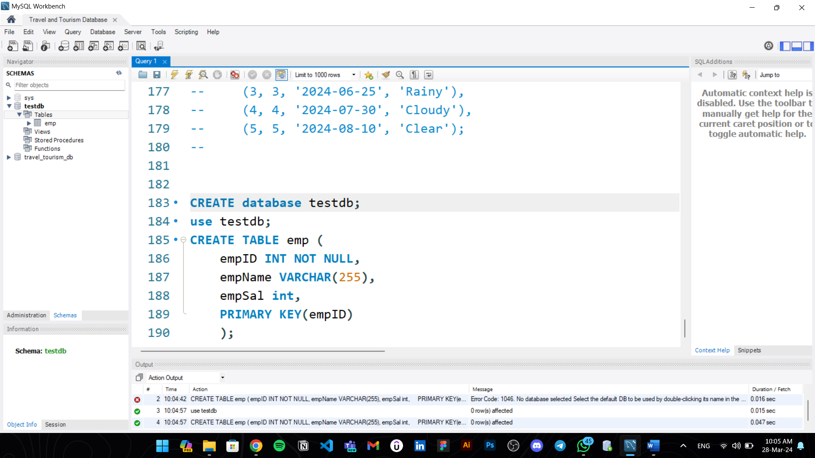

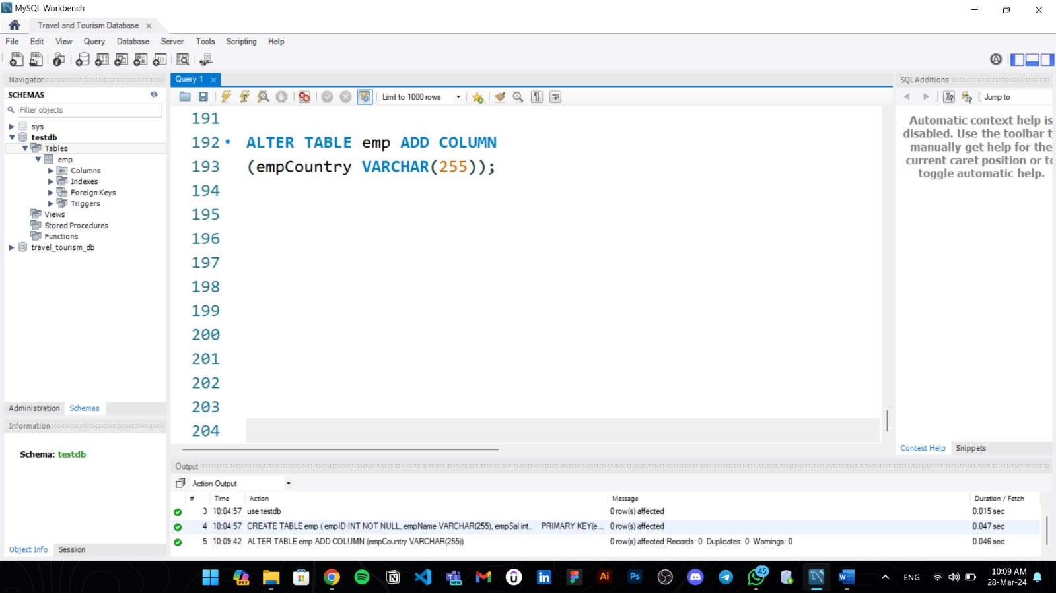**2. Alter Statement:**

**3. Rename Statement**

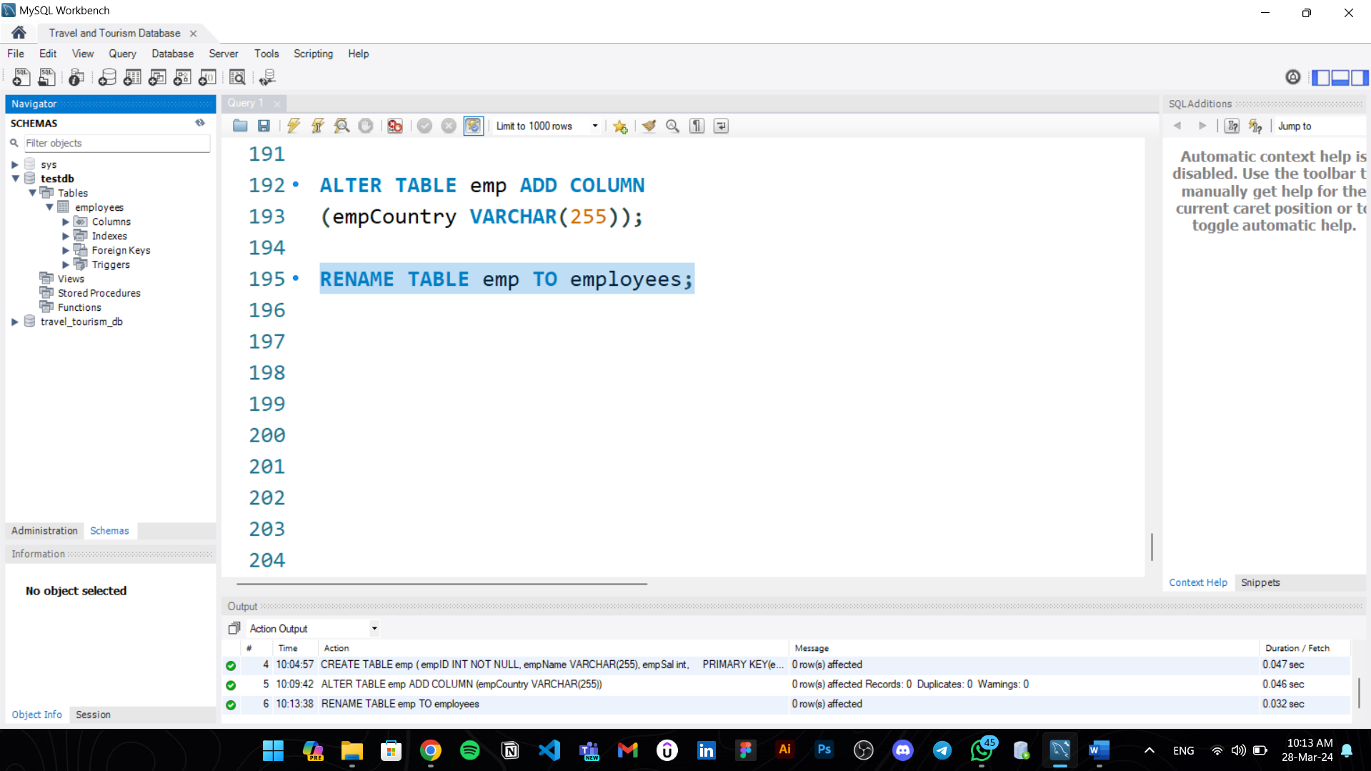

**4. Drop Statement**

